**Exploring the Ethereum dataset Available in BigQuery**

* **Log In** to google cloud with your **Google Account**

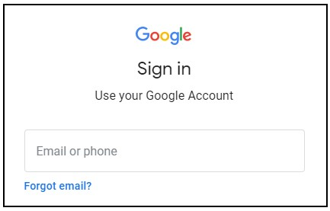

* Go to **Console.**

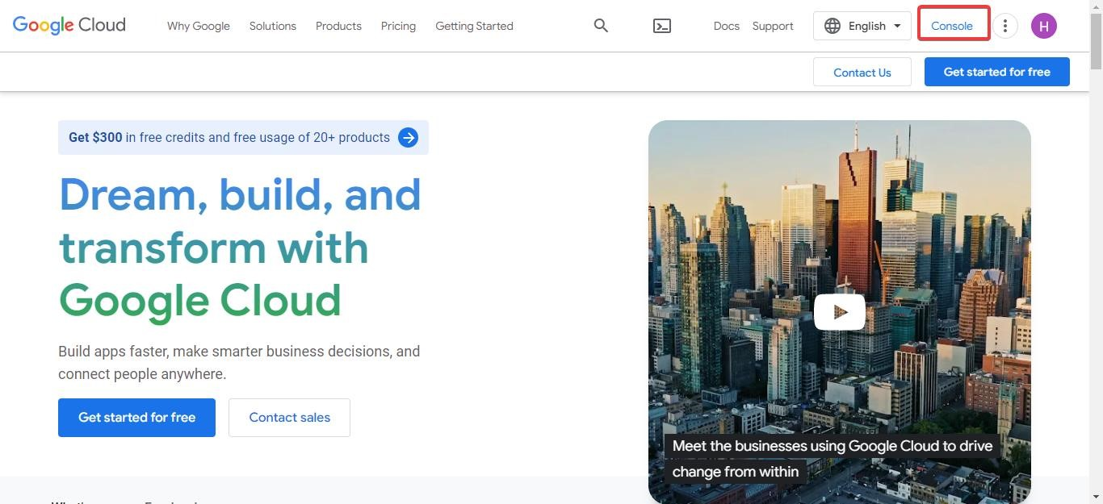

* Open **Navigation Menu > BigQuery**.

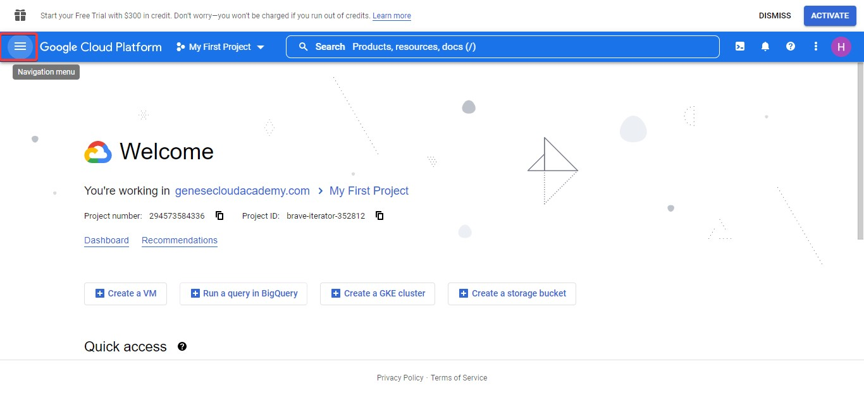

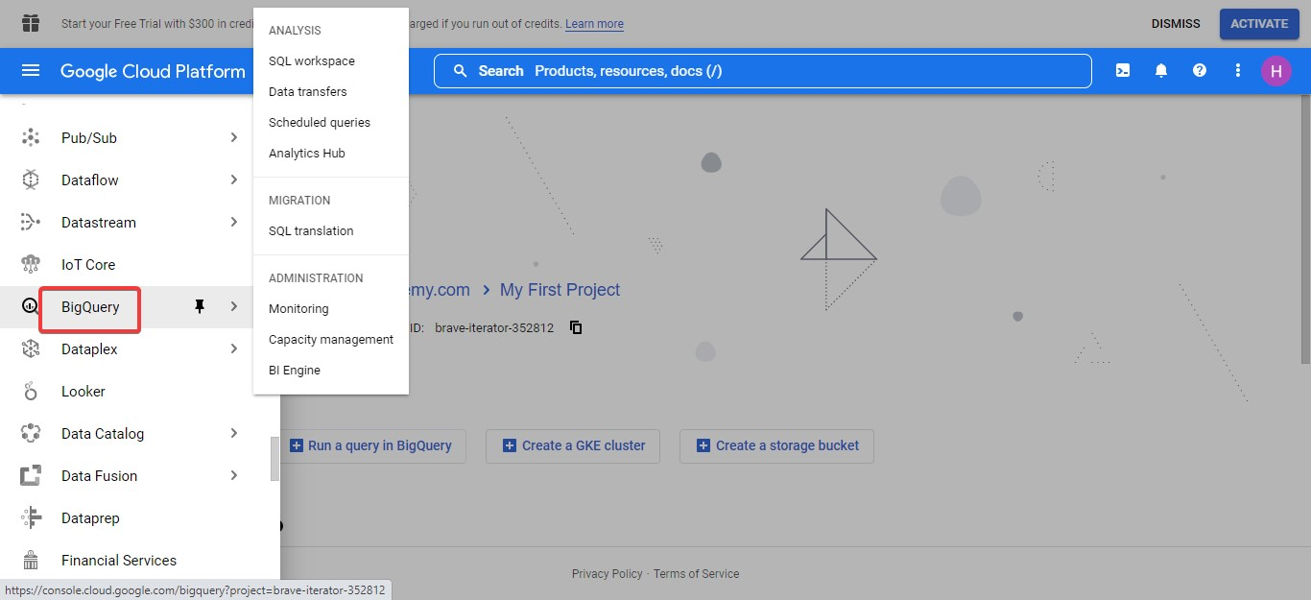

* The **Welcome to BigQuery in the Cloud Console** dailog box opens and click **DONE**.

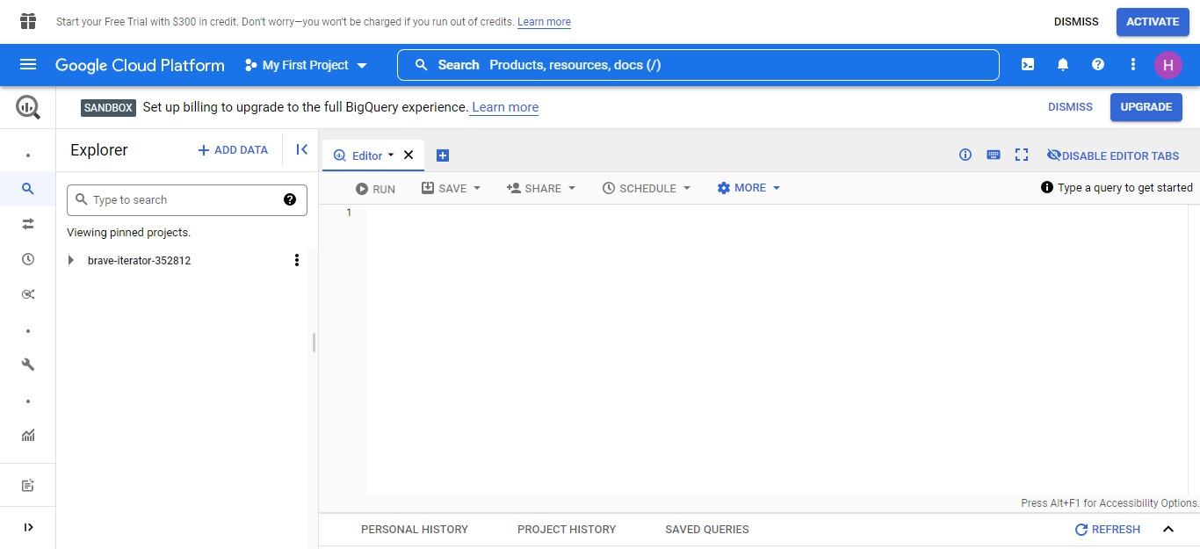

* Click **+ ADD DATA > Explore public datasets** .

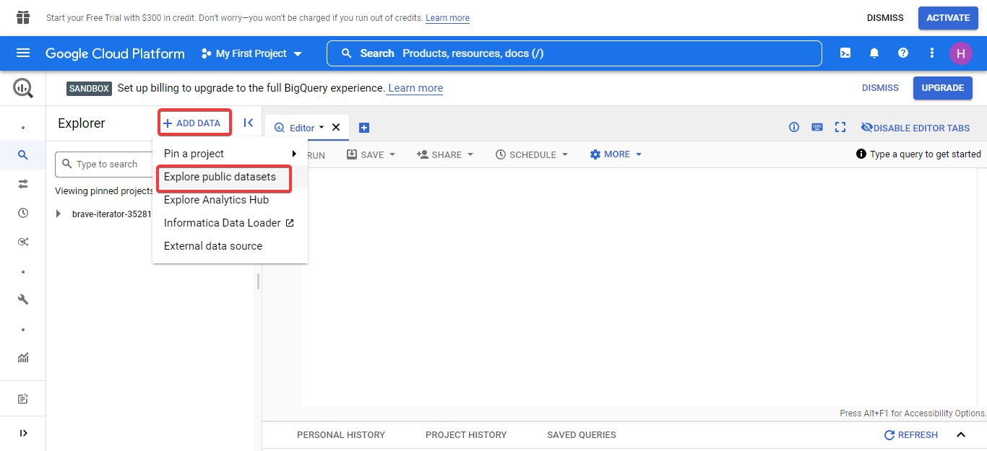

* In **Search for solutions**, type ethereum and press **enter**.

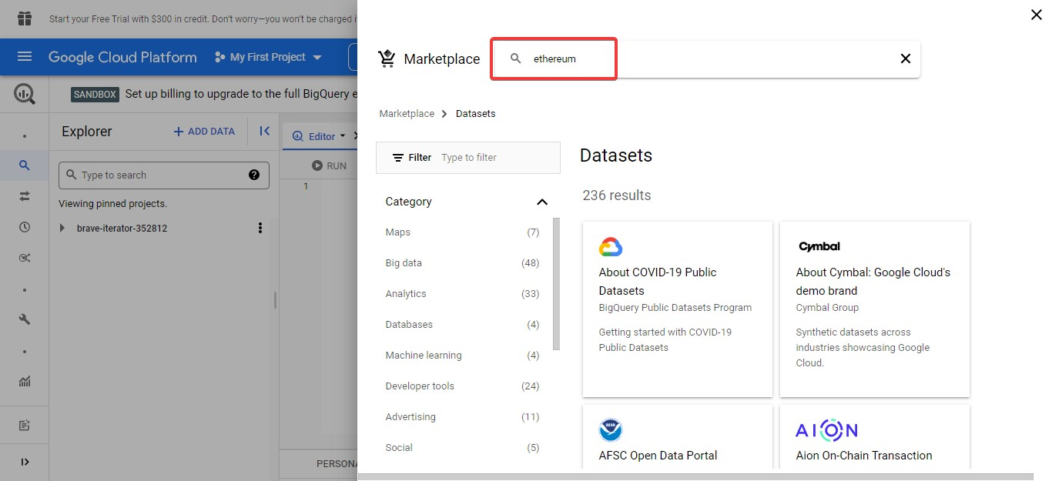

* Click Ethereum **Classic Cryptocurrency Dataset**

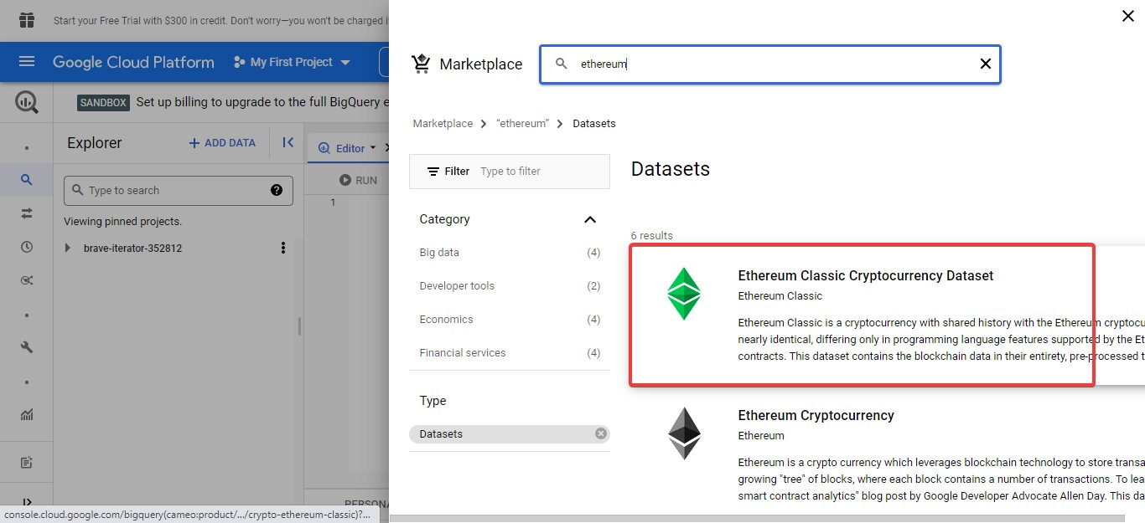

* Click **VIEW DATASET**

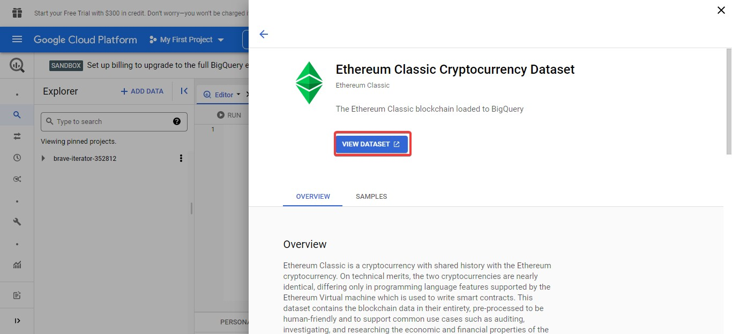

A new tab will open with BigQuery, and you should be on the bigquery-publicdata.crypto_ethereum_classic dataset.



* Click **+ Compose new query**.

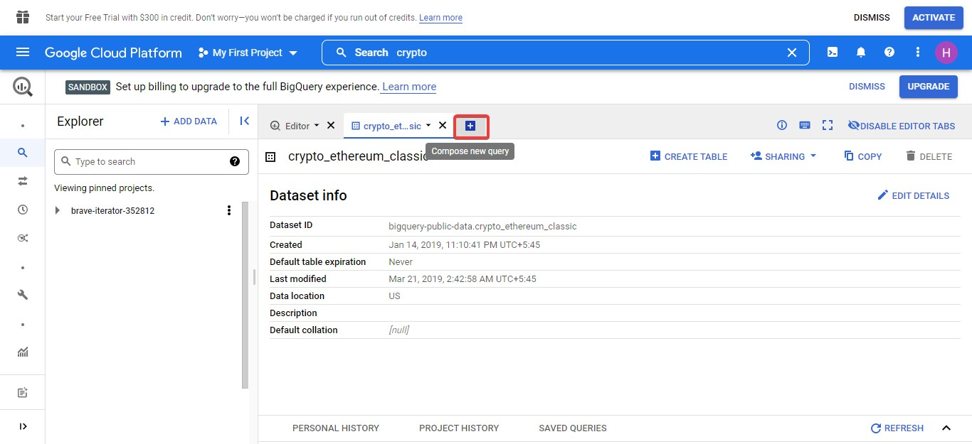

Copy and paste this query into the query window and then press Run.

#standardSQL select * from `bigquery-public-data.crypto_ethereum.balances` order by eth_balance desc limit 100000

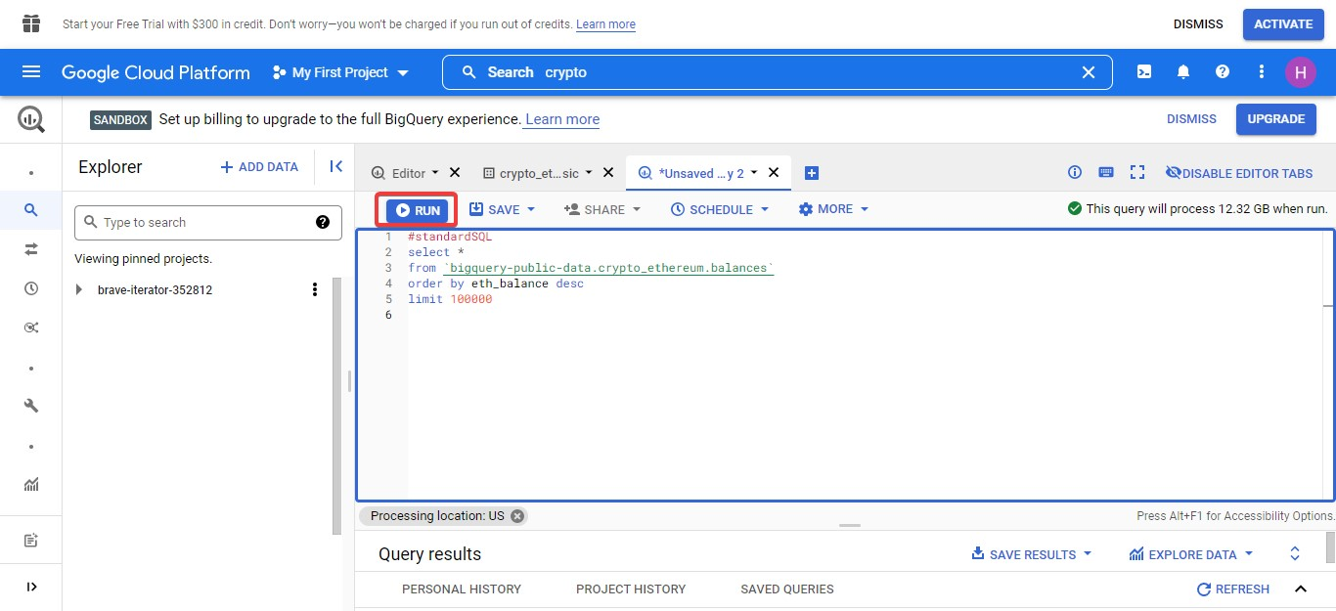

* Click **SAVE RESULTS**.

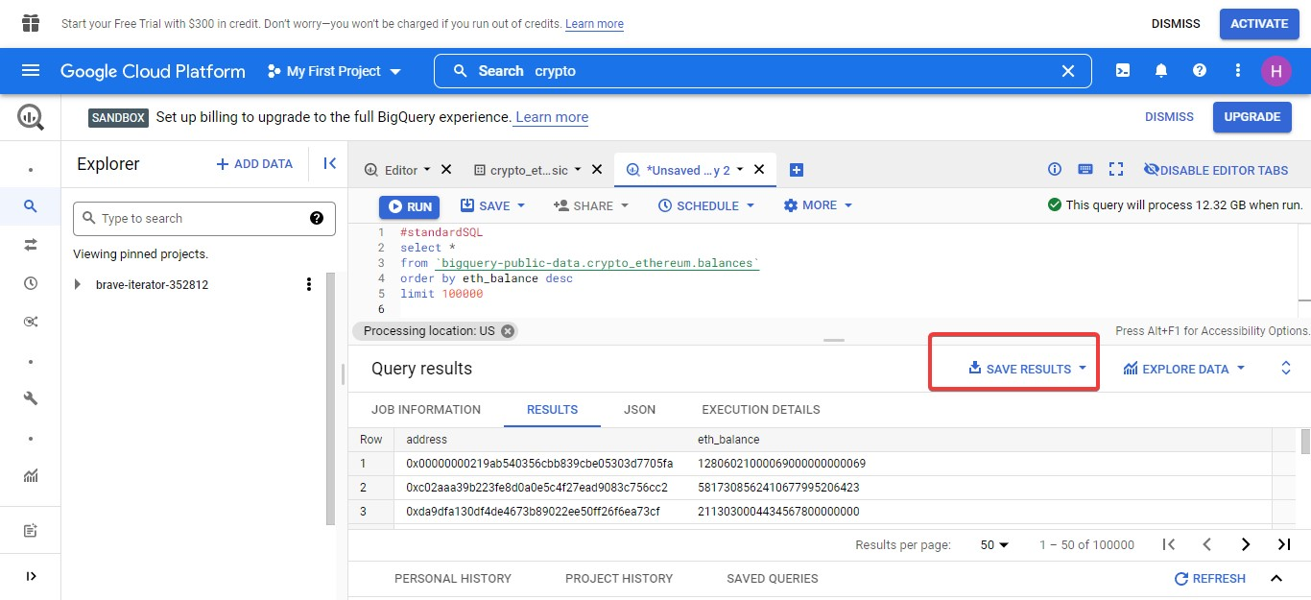

* Click CSV **(local file)** for download.

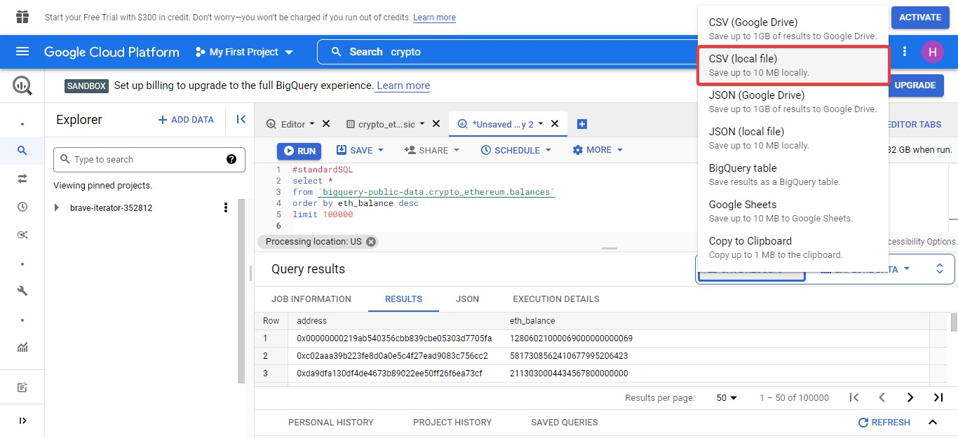

For unlimited query result,

# bigquery-public-data.crypto_ethereum.balances

#standardSQL

select *

from `bigquery-public-data.crypto_ethereum.balances`

order by eth_balance desc

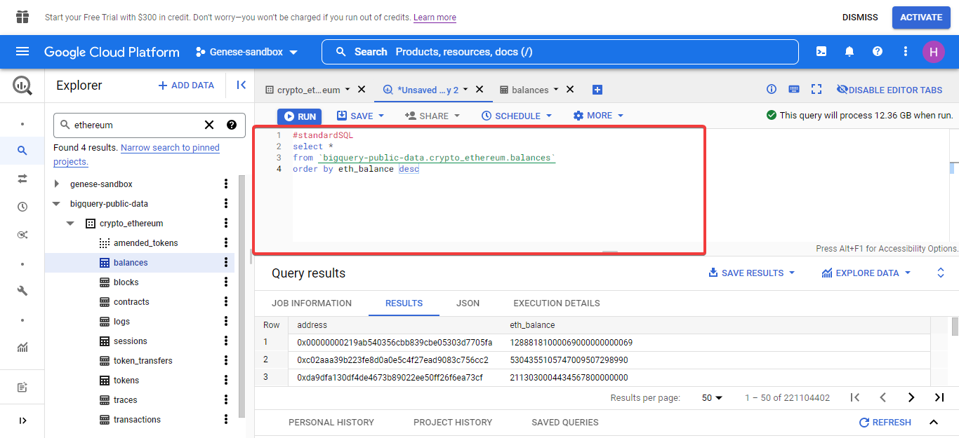

# bigquery-public-data.crypto_ethereum_classic.balances

#standardSQL

select *

from `bigquery-public-data.crypto_ethereum_classic.balances`

order by eth_balance desc

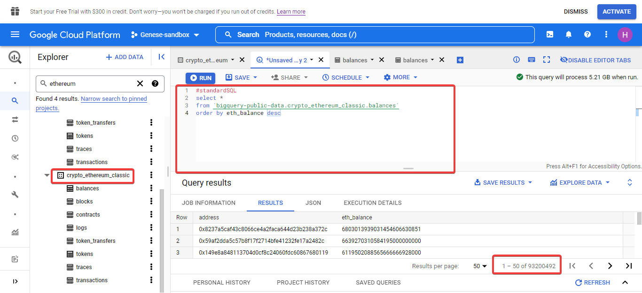

In order to prevent overlapping **bigquery-public-data.crypto_ethereum_classic** and **bigquery-public-data.crypto_ethereum.balances** in single output

Run the following code

#standardSQL

select address, eth_balance

from `bigquery-public-data.crypto_ethereum.balances*`

Union distinct

select address, eth_balance

from `bigquery-public-data.crypto_ethereum_classic.balances*`

order by eth_balance desc

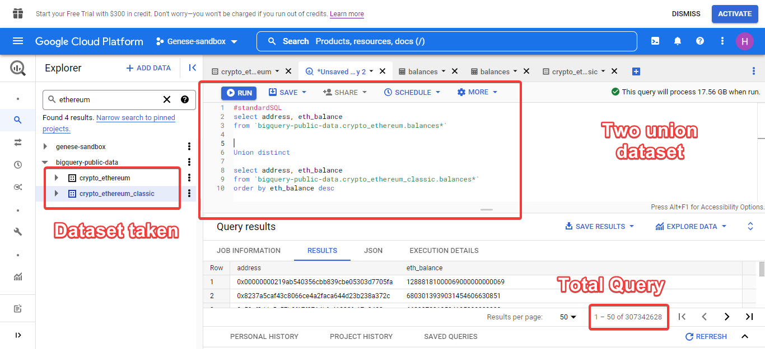

In order to overlapping, **bigquery-public-data.crypto_ethereum_classic** and **bigquery-public-data.crypto_ethereum.balances** in single output

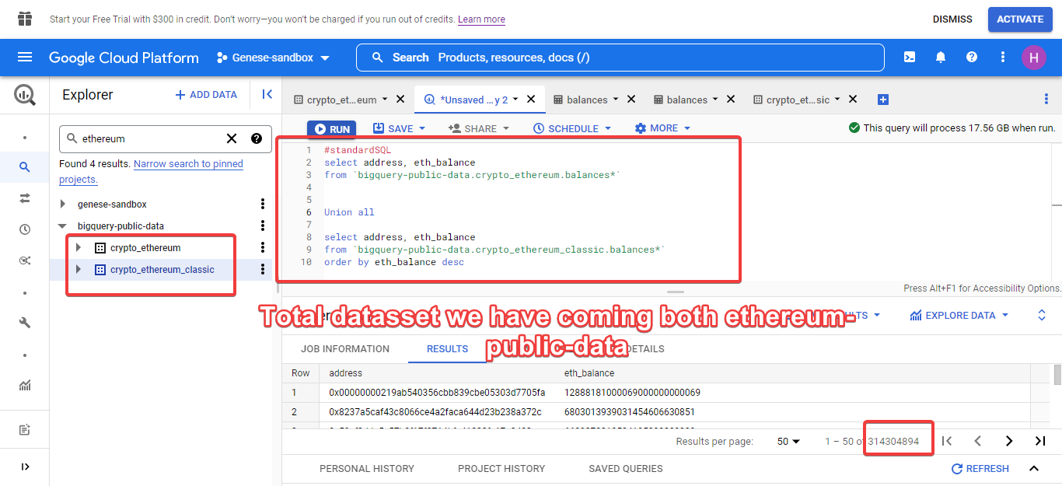

* Click **balances** on crypto_ethereum bigquery-public-data
* Click **Export**
* Click Export to GCS

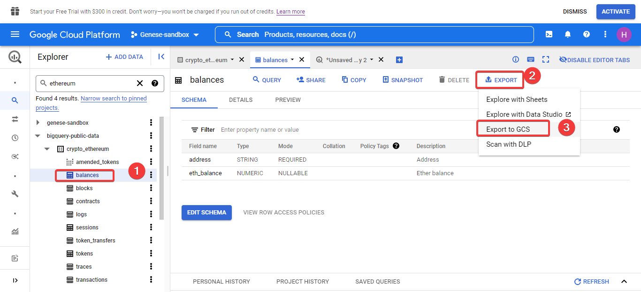

A dialogue box will appear

* Click **browse** to choose your bucket where you want to store your file.

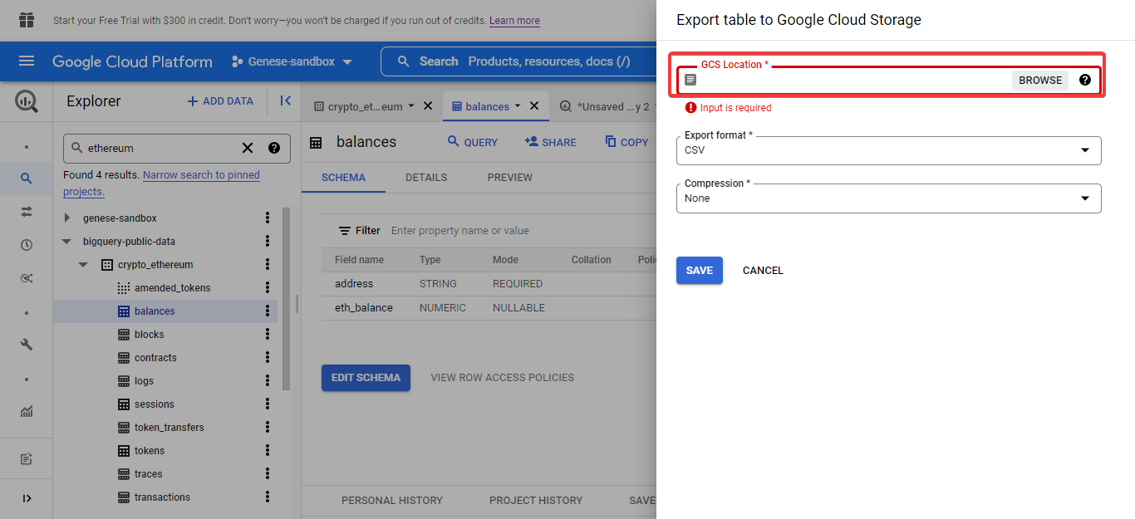

* Create new bucket.

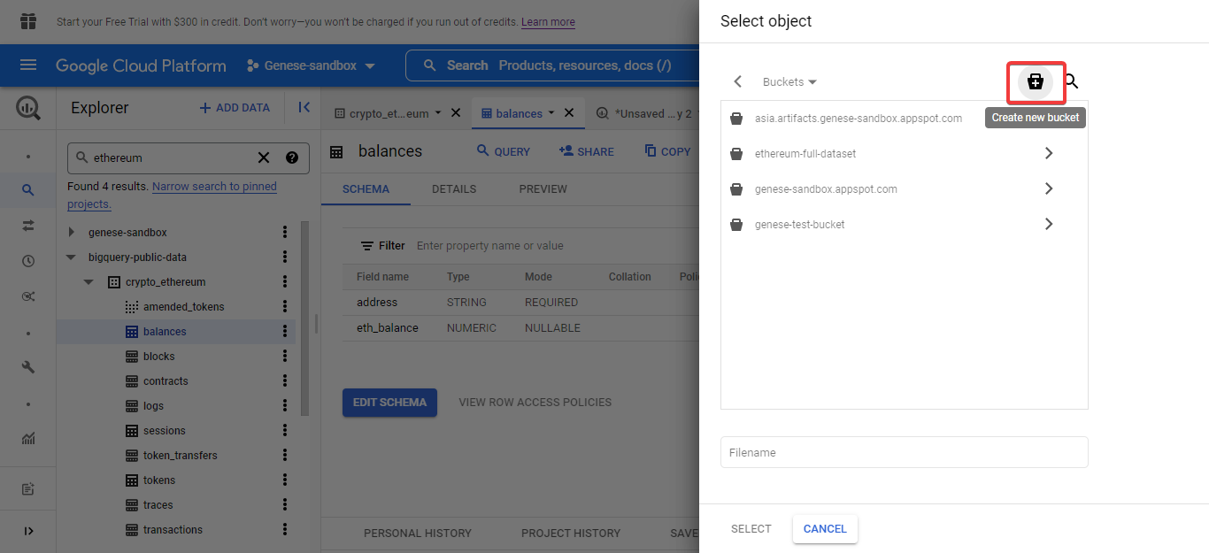

* Name your bucket and continue. Then.click **CREATE.**

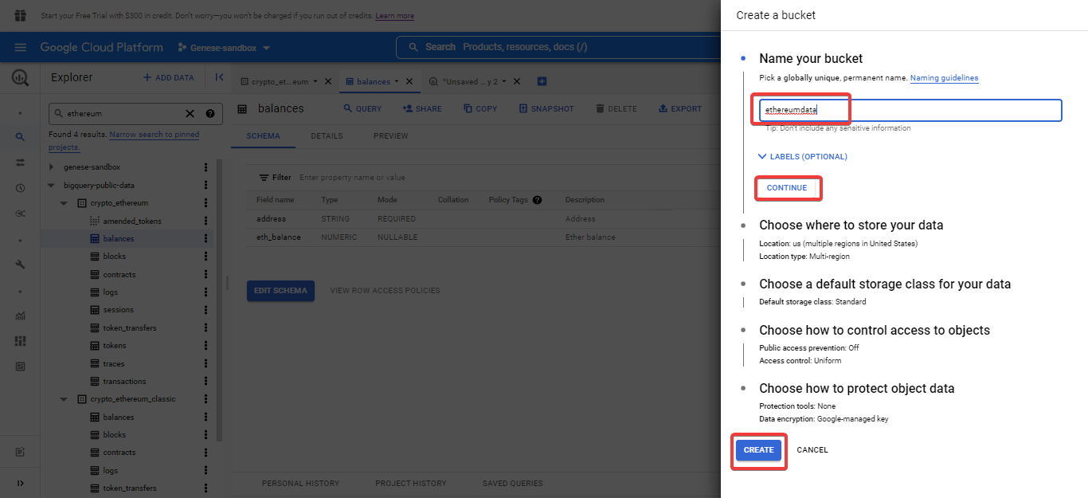

* Give a folder and file format you want to save on CSV or json file.
* Once completed Click Select.

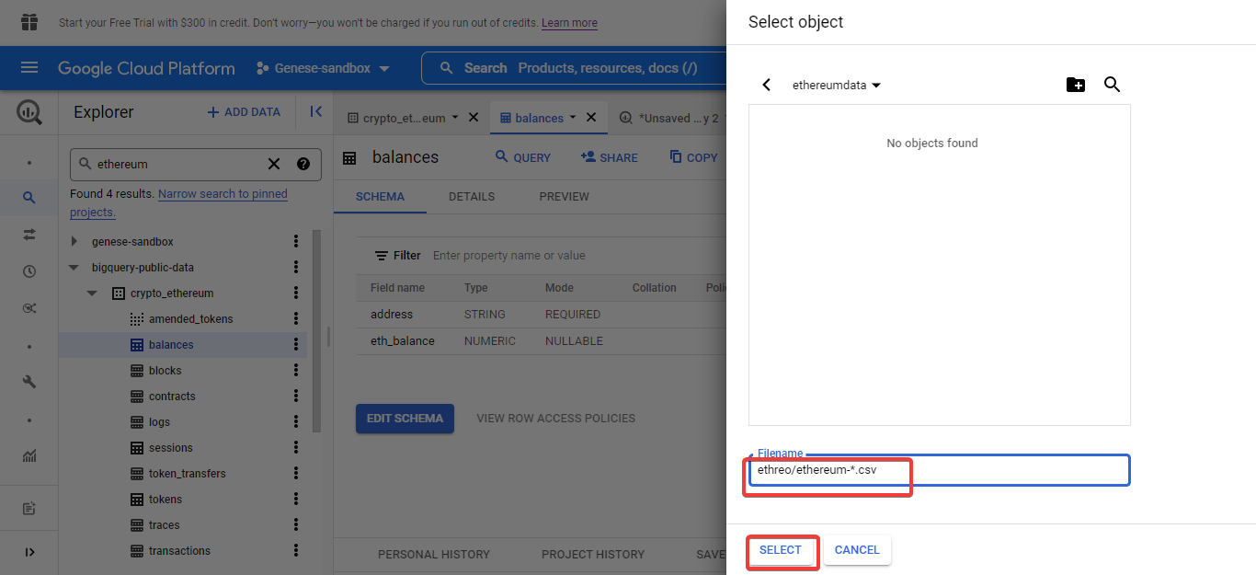

Lastly, we come into initial phase.

* Click **Save.**

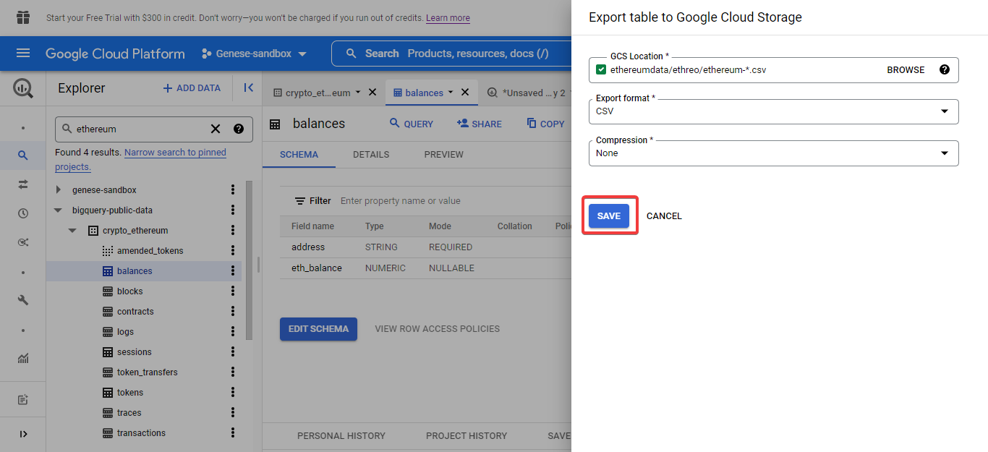

* Go to **Navigation** and Click **Cloud Storage.**

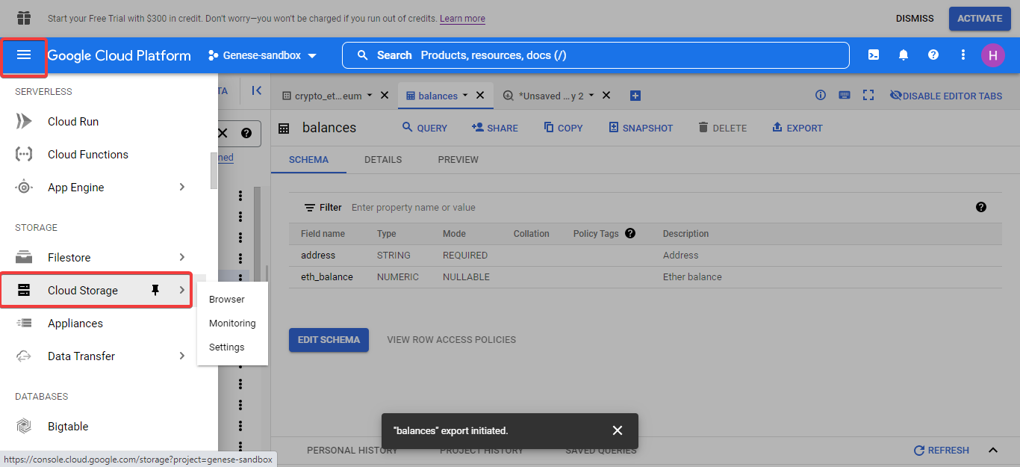

* Go to your bucket once you created and open the folder on it .

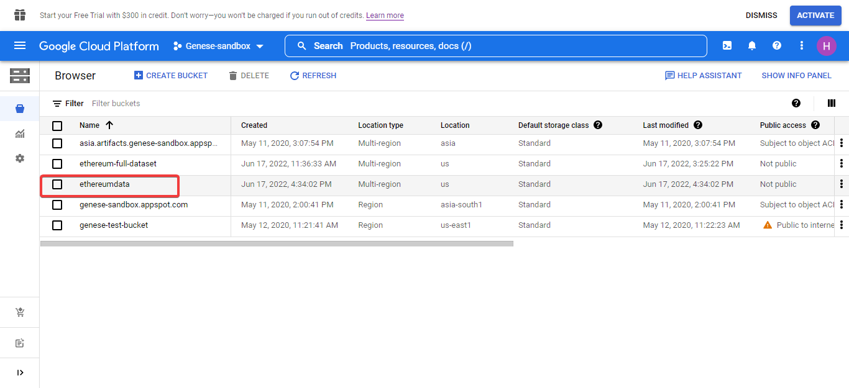

Finally you will see your files downloaded in segmented and numerical CSV files .

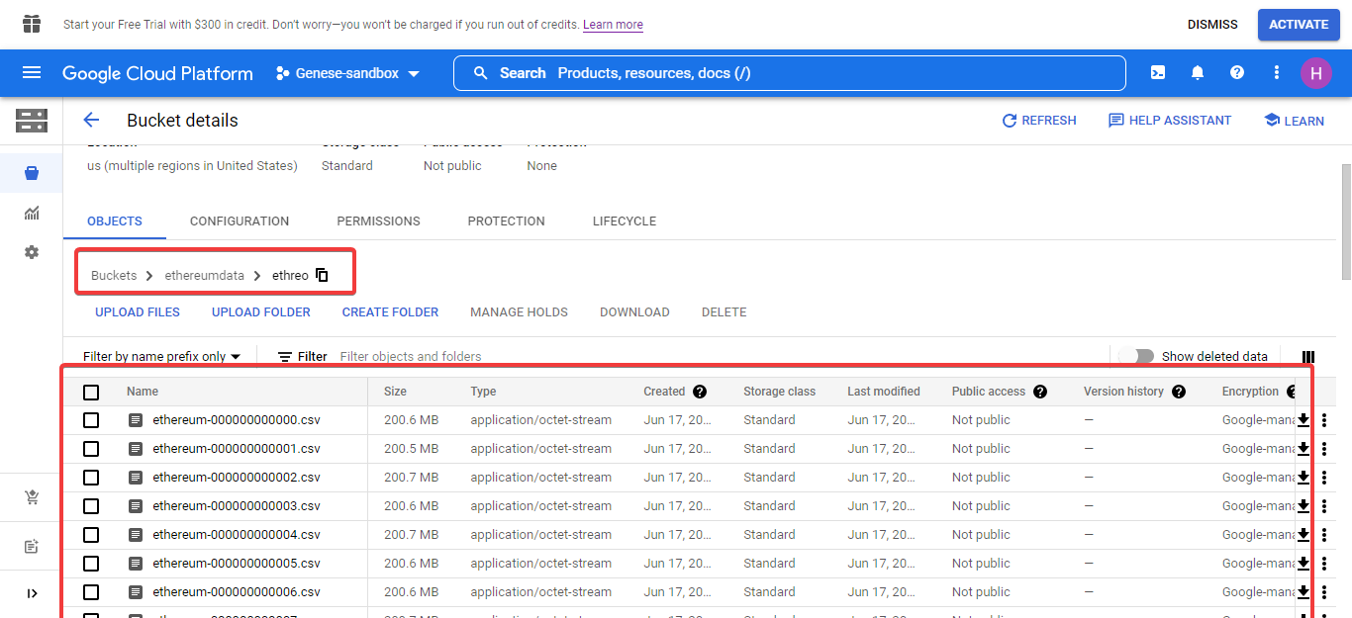

You can download file either using Activate Cloud Shell down-arrow button on corner.

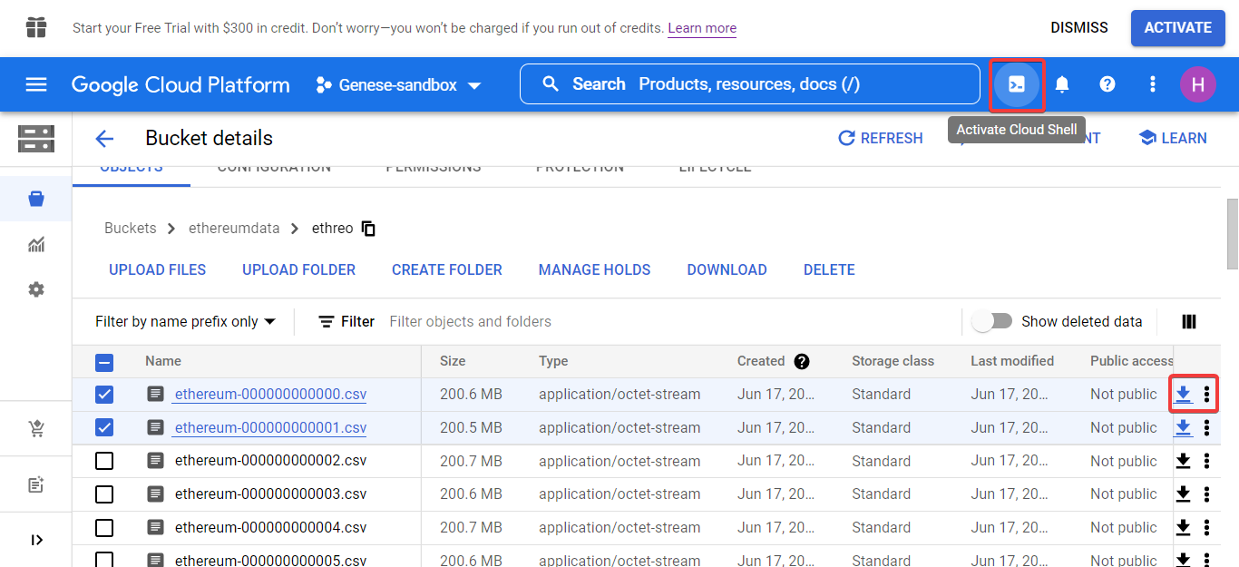

**Resources**

*💰 EthereumETL | Grants* (no date) *💰 EthereumETL | Grants*. Available at: <https://gitcoin.co/grants/233/ethereumetl> (Accessed: 17 June 2022).

*A Brief History of NFTs* (no date). Available at: <https://www.web3.university/tracks/build-your-first-nft/brief-history-of-nfts> (Accessed: 17 June 2022).

Adrianus Yoga (2022) *Coursera - Exporting data from BigQuery to Cloud Storage*. Available at: <https://www.youtube.com/watch?v=b6cV2W65s84> (Accessed: 17 June 2022).

*Analyse Ethereum transactions with Google BigQuery* (2020) *Anyblock Analytics*. Available at: <https://www.anyblockanalytics.com/blog/analyse-transactions-with-ethereum-google-bigquery-data-set/> (Accessed: 17 June 2022).

Banik, R. (2021) ‘Tutorial: Building a web3 frontend with React’, *Scrappy Squirrels*, 9 December. Available at: <https://medium.com/scrappy-squirrels/tutorial-building-a-web3-frontend-with-react-e0a87ea3bad> (Accessed: 17 June 2022).

BharatiDWConsultancy (2020) *GCP - BigQuery - Union ALL, DISTINCT & Wildcard * _Table_Suffix - DIY#6*. Available at: <https://www.youtube.com/watch?v=rAAeYt7Y7wQ> (Accessed: 17 June 2022).

BoostUpStation (2021) *Google Cloud Platform Credentials | Using OAuth 2.0 to Access Google APIs | Client ID, access token*. Available at: <https://www.youtube.com/watch?v=6MBLrH1j6Tg> (Accessed: 17 June 2022).

Brossard, E. (2017) ‘Answer to “Wildcard % operator not working on bigquery”’, *Stack Overflow*. Available at: <https://stackoverflow.com/a/44135182> (Accessed: 17 June 2022).

Buterin, V. (no date) ‘Ethereum: A Next-Generation Smart Contract and Decentralized Application Platform.’, p. 36.

*Cloud Storage client libraries* (no date) *Google Cloud*. Available at: <https://cloud.google.com/storage/docs/reference/libraries> (Accessed: 17 June 2022).

*CommandException: One or more URLs matched no objects. when I ran gsutil from Circle CI · Issue #1179 · GoogleCloudPlatform/gsutil* (no date) *GitHub*. Available at: <https://github.com/GoogleCloudPlatform/gsutil/issues/1179> (Accessed: 17 June 2022).

*Community guides and resources* (no date) *ethereum.org*. Available at: <https://ethereum.org> (Accessed: 17 June 2022).

*Creating New BigQuery Datasets and Visualizing Insights* (no date) *Coursera*. Available at: <https://www.coursera.org/learn/gcp-creating-bigquery-datasets-visualizing-insights?action=enroll> (Accessed: 17 June 2022).

CryptoKitties (no date) *CryptoKitties | Collect and breed digital cats!*, *CryptoKitties*. Available at: <https://www.cryptokitties.co> (Accessed: 17 June 2022).

*DappReview - Discover your next favourite decentralized App* (no date) *DappReview*. Available at: <https://dapp.review> (Accessed: 17 June 2022).

*Data to CSV, execution failed due to file size - bytemeta* (no date). Available at: <https://bytemeta.vip/repo/google/crmint/issues/150> (Accessed: 17 June 2022).

DataExpert (2021) *Extracting Data from Google Cloud BigQuery to your Database | CSV | Excel Using Talend*. Available at: <https://www.youtube.com/watch?v=Mv-DI8SmD84> (Accessed: 17 June 2022).

*Edit app registration – APIs & Services – Genese-sandbox – Google Cloud Platform* (no date a). Available at: <https://console.cloud.google.com/apis/credentials/consent/edit;newAppInternalUser=false?project=genese-sandbox> (Accessed: 17 June 2022).

*Edit app registration – APIs & Services – Genese-sandbox – Google Cloud Platform* (no date b). Available at: <https://console.cloud.google.com/apis/credentials/consent/edit;newAppInternalUser=false?project=genese-sandbox> (Accessed: 17 June 2022).

*Ethereum ETL Airflow* (2022). Blockchain ETL. Available at: <https://github.com/blockchain-etl/ethereum-etl-airflow> (Accessed: 17 June 2022).

*Ethereum (execution layer)* (no date). Available at: <https://docs.infura.io/infura/networks/ethereum> (Accessed: 17 June 2022).

*Ethereum Historical Dataset* (no date). Available at: <https://www.kaggle.com/prasoonkottarathil/ethereum-historical-dataset> (Accessed: 17 June 2022).

*Ethereum price today, ETH to USD live, marketcap and chart* (no date) *CoinMarketCap*. Available at: <https://coinmarketcap.com/currencies/ethereum/> (Accessed: 17 June 2022).

*ethereum/go-ethereum* (2022). ethereum. Available at: <https://github.com/ethereum/go-ethereum> (Accessed: 17 June 2022).

‘Export BigQuery Table to CSV: 3 Easy Methods’ (no date) *Learn | Hevo*. Available at: <https://hevodata.com/learn/export-bigquery-table-to-csv/> (Accessed: 17 June 2022).

*Exporting Data From BigQuery - Google BigQuery — Google Developers* (no date). Available at: <https://download.huihoo.com/google/gdgdevkit/DVD1/developers.google.com/bigquery/exporting-data-from-bigquery.html> (Accessed: 17 June 2022).

*Exporting data from BigQuery into Athena* (2018) *Big Data Demystified*. Available at: <https://big-data-demystified.ninja/2018/05/27/how-to-export-data-from-google-big-query-into-aws-s3-emr-hive/> (Accessed: 17 June 2022).

*Exporting table data | BigQuery* (no date) *Google Cloud*. Available at: <https://cloud.google.com/bigquery/docs/exporting-data> (Accessed: 17 June 2022).

*Exporting the Blockchain - Ethereum ETL* (no date). Available at: <https://ethereum-etl.readthedocs.io/en/latest/exporting-the-blockchain/> (Accessed: 17 June 2022).

*gcloud auth login error Code Example* (no date). Available at: <https://www.codegrepper.com/code-examples/whatever/gcloud+auth+login+error> (Accessed: 17 June 2022).

*Getting started with authentication | Authentication* (no date a) *Google Cloud*. Available at: <https://cloud.google.com/docs/authentication/getting-started> (Accessed: 17 June 2022).

*Getting started with authentication | Authentication* (no date b) *Google Cloud*. Available at: <https://cloud.google.com/docs/authentication/getting-started> (Accessed: 17 June 2022).

Google Cloud Tech (2015) *Getting started with Google Cloud Trace*. Available at: <https://www.youtube.com/watch?v=NCFDqeo7AeY> (Accessed: 17 June 2022).

Google Cloud Tech (2020) *BigQuery Web UI quickstart*. Available at: <https://www.youtube.com/watch?v=PqGqmzLYb8A> (Accessed: 17 June 2022).

‘google-auth Documentation’ (no date), p. 134.

*google.auth._default — google-auth 1.30.0 documentation* (no date). Available at: <https://google-auth.readthedocs.io/en/master/_modules/google/auth/_default.html> (Accessed: 17 June 2022).

*google.oauth2.service_account_async module — google-auth 1.30.0 documentation* (no date). Available at: <https://google-auth.readthedocs.io/en/master/reference/google.oauth2._service_account_async.html> (Accessed: 17 June 2022).

Hoffa, F. (2018) ‘Answer to “Exporting large file from BigQuery to Google cloud using wildcard”’, *Stack Overflow*. Available at: <https://stackoverflow.com/a/51415646> (Accessed: 17 June 2022).

*How to buy ETH* (no date) *ethereum.org*. Available at: <https://ethereum.org> (Accessed: 17 June 2022).

*How to Export BigQuery Data On a Schedule* (2021) *Coupler.io Blog*. Available at: <https://blog.coupler.io/bigquery-data-export/> (Accessed: 17 June 2022).

*How to export data from the BigQuery API with Python | Census* (2021) *Census Blog*. Available at: <https://blog.getcensus.com/how-to-hack-it-extracting-data-from-google-bigquery-with-python-2/> (Accessed: 17 June 2022).

*How to Export Data to a File in Google BigQuery* (no date) *Chartio*. Available at: <https://chartio.com/resources/tutorials/how-to-export-data-to-a-file-in-google-bigquery/> (Accessed: 17 June 2022).

*How to import Google BigQuery tables to AWS Athena* (2019) *freeCodeCamp.org*. Available at: <https://www.freecodecamp.org/news/how-to-import-google-bigquery-tables-to-aws-athena-5da842a13539/> (Accessed: 17 June 2022).

Hwang, Y. (2021) ‘Streaming Ethereum On-Chain Data to QuestDB’, *Geek Culture*, 12 April. Available at: <https://medium.com/geekculture/streaming-ethereum-on-chain-data-to-questdb-ea6b51d990ab> (Accessed: 17 June 2022).

Isan-Rivkin (2018) ‘How do you get all ERC20 tokens balances an address has? How do you sign transactions locally?’, *r/ethdev*. Available at: [www.reddit.com/r/ethdev/comments/84le1j/how_do_you_get_all_erc20_tokens_balances_an/](https://doi.org/www.reddit.com/r/ethdev/comments/84le1j/how_do_you_get_all_erc20_tokens_balances_an/) (Accessed: 17 June 2022).

jz22 (2021) ‘Google Cloud Load Balancer with wildcard’, *Server Fault*. Available at: <https://serverfault.com/q/1088518> (Accessed: 17 June 2022).

Kasireddy, P. (2019) ‘How does Ethereum work, anyway?’, *Medium*, 29 October. Available at: <https://preethikasireddy.medium.com/how-does-ethereum-work-anyway-22d1df506369> (Accessed: 17 June 2022).

Liang, J. (2018) ‘Ethereum’. Harvard Dataverse. doi:[10.7910/DVN/XIXSPR](https://doi.org/10.7910/DVN/XIXSPR).

LLC, G. (no date) *google-cloud-bigquery: Google BigQuery API client library* [OS Independent]. Available at: <https://github.com/googleapis/python-bigquery> (Accessed: 17 June 2022).

Lopp, J. (2019) ‘The Challenges of Building Ethereum Infrastructure’, *Medium*, 14 July. Available at: <https://medium.com/@lopp/the-challenges-of-building-ethereum-infrastructure-87e443e47a4b> (Accessed: 17 June 2022).

Marius (2017) ‘Answer to “Set GOOGLE_APPLICATION_CREDENTIALS in Python project to use Google API”’, *Stack Overflow*. Available at: <https://stackoverflow.com/a/46651026> (Accessed: 17 June 2022).

Medvedev, E. (2018) ‘Exporting and Analyzing Ethereum Blockchain’, *Medium*, 23 November. Available at: <https://evgemedvedev.medium.com/exporting-and-analyzing-ethereum-blockchain-f5353414a94e> (Accessed: 17 June 2022).

Medvedev, E. (2020) ‘How to Query Balances for all Ethereum Addresses in BigQuery’, *Google Cloud - Community*, 22 January. Available at: <https://medium.com/google-cloud/how-to-query-balances-for-all-ethereum-addresses-in-bigquery-fb594e4034a7> (Accessed: 17 June 2022).

Medvedev, E. (2021) ‘Query Ethereum Blockchain with SQL in Google BigQuery’, *Medium*, 24 February. Available at: <https://evgemedvedev.medium.com/ethereum-blockchain-on-google-bigquery-283fb300f579> (Accessed: 17 June 2022).

N, J. (2020) ‘How to export more than 16000 rows in bigquery table to local machine as CSV file?’, *Stack Overflow*. Available at: <https://stackoverflow.com/q/65108688> (Accessed: 17 June 2022).

Numpy Ninja (2021) *GCPDE-BigQuery wildcard tables*. Available at: <https://www.youtube.com/watch?v=u7Pd7fpZO4I> (Accessed: 17 June 2022).

Peace (2022) *A Labeled Transactions-Based Dataset on the Ethereum Network*. Available at: <https://github.com/salam-ammari/Labeled-Transactions-based-Dataset-of-Ethereum-Network> (Accessed: 17 June 2022).

Puccetti, A. (2020) ‘BigQuery Wildcards’, *Medium*, 21 January. Available at: <https://alepuccetti.medium.com/bigquery-wildcards-3aa155157484> (Accessed: 17 June 2022).

*Query multiple tables using a wildcard table | BigQuery* (no date) *Google Cloud*. Available at: <https://cloud.google.com/bigquery/docs/querying-wildcard-tables> (Accessed: 17 June 2022).

*Quickstart: Using client libraries | BigQuery* (no date) *Google Cloud*. Available at: <https://cloud.google.com/bigquery/docs/quickstarts/quickstart-client-libraries> (Accessed: 17 June 2022).

Qwiklabs (2019) ‘Hey, BigQuery!’, *Medium*, 19 February. Available at: <https://qwiklabs.medium.com/hey-bigquery-e9b5bdf786b0> (Accessed: 17 June 2022).

Siddiqui, I. (2020) ‘Solution To Extract Data From Ethereum’, *Coinmonks*, 1 September. Available at: <https://medium.com/coinmonks/solution-to-extract-data-from-ethereum-52d0b8007d1b> (Accessed: 17 June 2022).

‘[Solved] ImportError: No module named “google”’ (2021) *Exception Error*, 22 October. Available at: <https://exerror.com/importerror-no-module-named-google/> (Accessed: 17 June 2022).

Supermetrics (2019) *Supermetrics for BigQuery - How to extract the data you need with 3 query types*. Available at: <https://www.youtube.com/watch?v=5ZaOqEkyp8E> (Accessed: 17 June 2022).

Svanevik, A. (2020) ‘How to get any Ethereum smart contract into BigQuery (in 8 mins)’, *Medium*, 5 May. Available at: <https://medium.com/@ASvanevik/how-to-get-any-ethereum-smart-contract-into-bigquery-in-8-mins-bab5db1fdeee> (Accessed: 17 June 2022).

Tech Vine (2022) *ETL Processing on Google Cloud Using Dataflow and BigQuery || [GSP290] || Solution*. Available at: <https://www.youtube.com/watch?v=s7LufrmQsGQ> (Accessed: 17 June 2022).

*Three methods for exporting CSV files from BigQuery | Census* (2021) *Census Blog*. Available at: <https://blog.getcensus.com/3-ways-to-export-csv-files-from-google-bigquery/> (Accessed: 17 June 2022).

*Tutorial: How to query multiple ‘events_’ tables with ‘_table_suffix’ (GA4)* (2021) *GA4BigQuery*. Available at: <https://www.ga4bigquery.com/tutorial-how-to-query-multiple-analytics-events-tables-with-table-suffix-ga4/> (Accessed: 17 June 2022).

*Understanding Ethereum* (no date) *district0x Education Portal*. Available at: <https://education.district0x.io/general-topics/understanding-ethereum/> (Accessed: 17 June 2022).

*Use table wildcards for easy merges - Joining and Merging Datasets* (no date) *Coursera*. Available at: <https://www.coursera.org/lecture/gcp-creating-bigquery-datasets-visualizing-insights/use-table-wildcards-for-easy-merges-mKWIf> (Accessed: 17 June 2022).

*Using OAuth 2.0 for Web Server Applications | YouTube Data API* (no date) *Google Developers*. Available at: <https://developers.google.com/youtube/v3/guides/auth/server-side-web-apps> (Accessed: 17 June 2022).

*What Is Ethereum?* (no date) *district0x Education Portal*. Available at: <https://education.district0x.io/general-topics/understanding-ethereum/what-is-ethereum/> (Accessed: 17 June 2022).

Zheng, P., Zheng, Z. and Dai, H. (2019) ‘XBlock-ETH: Extracting and Exploring Blockchain Data From Ethereum’. arXiv. doi:[10.48550/arXiv.1911.00169](https://doi.org/10.48550/arXiv.1911.00169).

*BigQuery – My First Project – Google Cloud Platform* (no date). Available at: <https://console.cloud.google.com/bigquery(cameo:product/ethereum-classic/crypto-ethereum-classic)?project=brave-iterator-352812> (Accessed: 9 June 2022).

Career Ignite (2021) *Exploring the Public Cryptocurrency Datasets Available in BigQuery [GSP665] | Qwiklabs |Google Cloud*. Available at: <https://www.youtube.com/watch?v=2qyCbaQZ5TY> (Accessed: 9 June 2022).

Medvedev, E. (2020) ‘How to Query Balances for all Ethereum Addresses in BigQuery’, *Google Cloud - Community*, 22 January. Available at: <https://medium.com/google-cloud/how-to-query-balances-for-all-ethereum-addresses-in-bigquery-fb594e4034a7> (Accessed: 9 June 2022).

Qwiklabs (no date) *Exploring the Public Cryptocurrency Datasets Available in BigQuery | Google Cloud Skills Boost*, *Qwiklabs*. Available at: <https://www.cloudskillsboost.google/focuses/8486?parent=catalog> (Accessed: 9 June 2022).

*- Gitter* (no date). Available at: <https://gitter.im/ethereum/home> (Accessed: 9 June 2022).

‘7 Best Ethereum Wallets of 2022 [Updated] - Intellipaat’ (2021) *Intellipaat Blog*, 21 July. Available at: <https://intellipaat.com/blog/best-ethereum-wallets/> (Accessed: 9 June 2022).

*Accounts* (no date). Available at: <https://docs.etherscan.io/api-endpoints/accounts> (Accessed: 9 June 2022).

*Analyse Ethereum transactions with Google BigQuery* (2020) *Anyblock Analytics*. Available at: <https://www.anyblockanalytics.com/blog/analyse-transactions-with-ethereum-google-bigquery-data-set/> (Accessed: 17 June 2022).

*[ANN] Ethereum: Welcome to the Beginning* (no date). Available at: <https://bitcointalk.org/index.php?topic=428589.0> (Accessed: 10 June 2022).

axrd (2017) ‘Exporting Data using BigQuery multiple wildcard URIs’, *Stack Overflow*. Available at: <https://stackoverflow.com/q/46676579> (Accessed: 17 June 2022).

Berlyant, M. (2018) ‘Answer to “Error: Not found: Dataset my-project-name:domain_public was not found in location US”’, *Stack Overflow*. Available at: <https://stackoverflow.com/a/51395375> (Accessed: 17 June 2022).

*Best practices to securely authenticate applications in Google Cloud  |  Authentication* (no date). Available at: <https://cloud.google.com/docs/authentication/best-practices-applications> (Accessed: 17 June 2022).

*Best practices to securely authenticate applications in Google Cloud | Authentication* (no date) *Google Cloud*. Available at: <https://cloud.google.com/docs/authentication/best-practices-applications> (Accessed: 17 June 2022).

BharatiDWConsultancy (2020) *GCP - BigQuery - Union ALL, DISTINCT & Wildcard * _Table_Suffix - DIY#6*. Available at: <https://www.youtube.com/watch?v=rAAeYt7Y7wQ> (Accessed: 17 June 2022).

‘BigQuery Wildcard Tables 101: Syntax and Usage Simplified’ (no date) *Learn | Hevo*. Available at: <https://hevodata.com/learn/bigquery-wildcard/> (Accessed: 17 June 2022).

Brossard, E. (2017) ‘Answer to “Handle gsutil ls and rm command errors if no files present”’, *Stack Overflow*. Available at: <https://stackoverflow.com/a/42933238> (Accessed: 17 June 2022).

BscScan.com (no date) *Binance-Peg Ethereum Token (ETH) Token Tracker | BscScan*, *Binance (BNB) Blockchain Explorer*. Available at: <http://bscscan.com/token/0x2170ed0880ac9a755fd29b2688956bd959f933f8> (Accessed: 9 June 2022).

Buterin, V. (no date) ‘Ethereum: A Next-Generation Smart Contract and Decentralized Application Platform.’, p. 36.

*Cloud Storage URI, - YouTube* (no date). Available at: <https://www.youtube.com/results?search_query=Cloud+Storage+URI%2C+> (Accessed: 17 June 2022).

*Community guides and resources* (no date) *ethereum.org*. Available at: <https://ethereum.org> (Accessed: 17 June 2022).

*Create access credentials | Google Workspace for Developers* (no date) *Google Developers*. Available at: <https://developers.google.com/workspace/guides/create-credentials> (Accessed: 17 June 2022).

CryptoKitties (no date) *CryptoKitties | Collect and breed digital cats!*, *CryptoKitties*. Available at: <https://www.cryptokitties.co> (Accessed: 17 June 2022).

dang huy (2020) *Exploring the Public Cryptocurrency Datasets Available in BigQuery*. Available at: <https://www.youtube.com/watch?v=HhhFRS028dM> (Accessed: 9 June 2022).

*Data to CSV, execution failed due to file size - bytemeta* (no date). Available at: <https://bytemeta.vip/repo/google/crmint/issues/150> (Accessed: 17 June 2022).

DataExpert (2021) *Extracting Data from Google Cloud BigQuery to your Database | CSV | Excel Using Talend*. Available at: <https://www.youtube.com/watch?v=Mv-DI8SmD84> (Accessed: 17 June 2022).

‘Ethereum’ (2022) *Wikipedia*. Available at: <https://en.wikipedia.org/w/index.php?title=Ethereum&oldid=1091953135> (Accessed: 10 June 2022).

*ethereum* (no date) *GitHub*. Available at: <https://github.com/ethereum> (Accessed: 10 June 2022).

*Ethereum API Specification* (2022). ethereum. Available at: <https://github.com/ethereum/execution-apis> (Accessed: 9 June 2022).

*Ethereum Community Forum* (no date) *Ethereum Community Forum*. Available at: [https://wayback.archive-it.org/16516/20210618210825/https://forum.ethereum.org/](https://wayback.archive-it.org/16516/20210618210825/https:/forum.ethereum.org/) (Accessed: 10 June 2022).

*Ethereum (@ethereum) / Twitter* (no date) *Twitter*. Available at: <https://twitter.com/ethereum> (Accessed: 10 June 2022).

*Ethereum ETL* (2022). Blockchain ETL. Available at: <https://github.com/blockchain-etl/ethereum-etl> (Accessed: 17 June 2022).

*Ethereum ETL Airflow* (2022). Blockchain ETL. Available at: <https://github.com/blockchain-etl/ethereum-etl-airflow> (Accessed: 17 June 2022).

*Ethereum (execution layer)* (no date). Available at: <https://docs.infura.io/infura/networks/ethereum> (Accessed: 17 June 2022).

*Ethereum Explorer* (no date). Available at: <https://blockchair.com/ethereum> (Accessed: 10 June 2022).

*Ethereum Research* (no date) *Ethereum Research*. Available at: <https://ethresear.ch/> (Accessed: 10 June 2022).

*Ethereum USD (ETH-USD) Historical Prices Since Ethereum Price issued* (no date) *CoinCarp*. Available at: <https://www.coincarp.com/currencies/ethereum/history/> (Accessed: 9 June 2022).

*ethereum/go-ethereum* (2022a). ethereum. Available at: <https://github.com/ethereum/go-ethereum> (Accessed: 9 June 2022).

*ethereum/go-ethereum* (2022b). ethereum. Available at: <https://github.com/ethereum/go-ethereum> (Accessed: 10 June 2022).

etherscan.io (no date a) *Ethereum (ETH) Blockchain Explorer*, *Ethereum (ETH) Blockchain Explorer*. Available at: <http://etherscan.io/> (Accessed: 9 June 2022).

etherscan.io (no date b) *Ethereum Top Accounts by ETH Balance | Etherscan*, *Ethereum (ETH) Blockchain Explorer*. Available at: <http://etherscan.io/accounts> (Accessed: 9 June 2022).

*Ethplorer — Explorador de tokens de Ethereum y visor de datos. Principales tokens, Gráficos, Capitalización, Analítica* (no date). Available at: <https://ethplorer.io/es> (Accessed: 10 June 2022).

*export_data_from_bq_to_gcs.ipynb - Colaboratory* (no date). Available at: <https://colab.research.google.com/drive/1TJiXvYNePXDd1176tqbT_X13MIRNCx2A#scrollTo=Q00Y2Y1sl4hA> (Accessed: 17 June 2022).

*Exporting Data From BigQuery - Google BigQuery — Google Developers* (no date). Available at: <https://download.huihoo.com/google/gdgdevkit/DVD1/developers.google.com/bigquery/exporting-data-from-bigquery.html> (Accessed: 17 June 2022).

*Exporting data from BigQuery into Athena* (2018) *Big Data Demystified*. Available at: <https://big-data-demystified.ninja/2018/05/27/how-to-export-data-from-google-big-query-into-aws-s3-emr-hive/> (Accessed: 17 June 2022).

*Exporting table data | BigQuery* (no date a) *Google Cloud*. Available at: <https://cloud.google.com/bigquery/docs/exporting-data> (Accessed: 17 June 2022).

*Exporting table data | BigQuery* (no date b) *Google Cloud*. Available at: <https://cloud.google.com/bigquery/docs/exporting-data> (Accessed: 17 June 2022).

*Exporting table data  |  BigQuery  |  Google Cloud* (no date). Available at: <https://cloud.google.com/bigquery/docs/exporting-data> (Accessed: 17 June 2022).

*Extract, transform, and load data in Google BigQuery* (no date) *Etlworks Support*. Available at: <https://support.etlworks.com/hc/en-us/articles/4404082985491-Extract-transform-and-load-data-in-Google-BigQuery> (Accessed: 17 June 2022).

*GCPDE-BigQuery wildcard tables - YouTube* (no date a). Available at: <https://www.youtube.com/watch?v=u7Pd7fpZO4I> (Accessed: 17 June 2022).

*GCPDE-BigQuery wildcard tables - YouTube* (no date b). Available at: <https://www.youtube.com/watch?v=u7Pd7fpZO4I> (Accessed: 17 June 2022).

*Getting Started* (no date) *OpenTelemetry*. Available at: <https://opentelemetry.io/docs/instrumentation/python/getting-started/> (Accessed: 17 June 2022).

*Getting started with authentication | Authentication* (no date a) *Google Cloud*. Available at: <https://cloud.google.com/docs/authentication/getting-started> (Accessed: 17 June 2022).

*Getting started with authentication | Authentication* (no date b) *Google Cloud*. Available at: <https://cloud.google.com/docs/authentication/getting-started> (Accessed: 17 June 2022).

‘google-auth Documentation’ (no date), p. 134.

Hiltch, O. (2019) ‘Connecting to Google BigQuery from AWS SageMaker’, *Skyline AI*, 5 April. Available at: <https://medium.com/skyline-ai/connecting-to-google-bigquery-from-aws-sagemaker-eb0e3c7556de> (Accessed: 17 June 2022).

*Home* (no date) *ethereum.org*. Available at: <https://ethereum.org> (Accessed: 10 June 2022).

*How does Ethereum work, anyway?. Introduction | by Preethi Kasireddy | Medium* (no date). Available at: <https://preethikasireddy.medium.com/how-does-ethereum-work-anyway-22d1df506369> (Accessed: 17 June 2022).

*How to Export BigQuery Data On a Schedule* (2021) *Coupler.io Blog*. Available at: <https://blog.coupler.io/bigquery-data-export/> (Accessed: 17 June 2022).

*How to export data from the BigQuery API with Python | Census* (2021) *Census Blog*. Available at: <https://blog.getcensus.com/how-to-hack-it-extracting-data-from-google-bigquery-with-python-2/> (Accessed: 17 June 2022).

*How to Export Data to a File in Google BigQuery* (no date) *Chartio*. Available at: <https://chartio.com/resources/tutorials/how-to-export-data-to-a-file-in-google-bigquery/> (Accessed: 17 June 2022).

*How to import Google BigQuery tables to AWS Athena* (2019) *freeCodeCamp.org*. Available at: <https://www.freecodecamp.org/news/how-to-import-google-bigquery-tables-to-aws-athena-5da842a13539/> (Accessed: 17 June 2022).

*How to search/create game nft /bored ape nft /solana nft /erc721 token with Tokenview* (no date). Available at: <https://eth.tokenview.com/en/blocklist> (Accessed: 10 June 2022).

Hwang, Y. (2021) ‘Streaming Ethereum On-Chain Data to QuestDB’, *Geek Culture*, 12 April. Available at: <https://medium.com/geekculture/streaming-ethereum-on-chain-data-to-questdb-ea6b51d990ab> (Accessed: 17 June 2022).

*Introducing six new cryptocurrencies in BigQuery Public Datasets—and how to analyze them* (no date) *Google Cloud Blog*. Available at: <https://cloud.google.com/blog/products/data-analytics/introducing-six-new-cryptocurrencies-in-bigquery-public-datasets-and-how-to-analyze-them/> (Accessed: 9 June 2022).

Jackson, J.T. (2022) *Shmoji/token-balance-example*. Available at: <https://github.com/Shmoji/token-balance-example> (Accessed: 9 June 2022).

jz22 (2021) ‘Google Cloud Load Balancer with wildcard’, *Server Fault*. Available at: <https://serverfault.com/q/1088518> (Accessed: 17 June 2022).

Marius (2017) ‘Answer to “Set GOOGLE_APPLICATION_CREDENTIALS in Python project to use Google API”’, *Stack Overflow*. Available at: <https://stackoverflow.com/a/46651026> (Accessed: 17 June 2022).

Medvedev, E. (2018) ‘Exporting and Analyzing Ethereum Blockchain’, *Medium*, 23 November. Available at: <https://evgemedvedev.medium.com/exporting-and-analyzing-ethereum-blockchain-f5353414a94e> (Accessed: 17 June 2022).

Medvedev, E. (2020a) ‘How to Query Balances for all Ethereum Addresses in BigQuery’, *Google Cloud - Community*, 22 January. Available at: <https://medium.com/google-cloud/how-to-query-balances-for-all-ethereum-addresses-in-bigquery-fb594e4034a7> (Accessed: 10 June 2022).

Medvedev, E. (2020b) ‘How to Query Balances for all Ethereum Addresses in BigQuery’, *Google Cloud - Community*, 22 January. Available at: <https://medium.com/google-cloud/how-to-query-balances-for-all-ethereum-addresses-in-bigquery-fb594e4034a7> (Accessed: 17 June 2022).

Medvedev, E. (2021) ‘Query Ethereum Blockchain with SQL in Google BigQuery’, *Medium*, 24 February. Available at: <https://evgemedvedev.medium.com/ethereum-blockchain-on-google-bigquery-283fb300f579> (Accessed: 17 June 2022).

Moralis Web3 (2021) *Get All ERC20 Tokens Owned By User - Ethereum Token Balances*. Available at: <https://www.youtube.com/watch?v=UiLI9WlNBGQ> (Accessed: 9 June 2022).

Moriya, H. (2018) ‘How to get Ethereum balance with JSON RPC API provided by infura.io’, *Medium*, 20 August. Available at: <https://piyopiyo.medium.com/how-to-get-ethereum-balance-with-json-rpc-api-provided-by-infura-io-6e5d22d25927> (Accessed: 9 June 2022).

Ocando, D. (2020) ‘Answer to “How to export more than 16000 rows in bigquery table to local machine as CSV file?”’, *Stack Overflow*. Available at: <https://stackoverflow.com/a/65109557> (Accessed: 17 June 2022).

*OpenTelemetry Python API — OpenTelemetry Python documentation* (no date). Available at: <https://opentelemetry-python.readthedocs.io/en/latest/api/index.html> (Accessed: 17 June 2022).

Peace (2022) *A Labeled Transactions-Based Dataset on the Ethereum Network*. Available at: <https://github.com/salam-ammari/Labeled-Transactions-based-Dataset-of-Ethereum-Network/blob/b97398be48ef8e69adddda80c731dfa24f87685b/Dataset.zip> (Accessed: 17 June 2022).

Puccetti, A. (2020) ‘BigQuery Wildcards’, *Medium*, 21 January. Available at: <https://alepuccetti.medium.com/bigquery-wildcards-3aa155157484> (Accessed: 17 June 2022).

*Query multiple tables using a wildcard table | BigQuery* (no date) *Google Cloud*. Available at: <https://cloud.google.com/bigquery/docs/querying-wildcard-tables> (Accessed: 17 June 2022).

*Query multiple tables using a wildcard table  |  BigQuery  |  Google Cloud* (no date). Available at: <https://cloud.google.com/bigquery/docs/querying-wildcard-tables#best_practices> (Accessed: 17 June 2022).

*Query multiple tables using a wildcard table in big query - YouTube* (no date). Available at: <https://www.youtube.com/results?search_query=Query+multiple+tables+using+a+wildcard+table+in+big+query+> (Accessed: 17 June 2022).

*Quickstart: Using client libraries | BigQuery* (no date) *Google Cloud*. Available at: <https://cloud.google.com/bigquery/docs/quickstarts/quickstart-client-libraries> (Accessed: 17 June 2022).

Qwiklabs (2019) ‘Hey, BigQuery!’, *Medium*, 19 February. Available at: <https://qwiklabs.medium.com/hey-bigquery-e9b5bdf786b0> (Accessed: 17 June 2022).

Ruscica, T. (2022) *Ethereum-Wallet-Tracker*. Available at: <https://github.com/techwithtim/Ethereum-Wallet-Tracker> (Accessed: 9 June 2022).

*Solution To Extract Data From Ethereum | by Ibad Siddiqui | Coinmonks | Medium* (no date). Available at: <https://medium.com/coinmonks/solution-to-extract-data-from-ethereum-52d0b8007d1b> (Accessed: 17 June 2022).

‘[Solved] ImportError: No module named “google”’ (2021) *Exception Error*, 22 October. Available at: <https://exerror.com/importerror-no-module-named-google/> (Accessed: 17 June 2022).

Svanevik, A. (2020) ‘How to get any Ethereum smart contract into BigQuery (in 8 mins)’, *Medium*, 5 May. Available at: <https://medium.com/@ASvanevik/how-to-get-any-ethereum-smart-contract-into-bigquery-in-8-mins-bab5db1fdeee> (Accessed: 17 June 2022).

*SyntaxError: (unicode error) ‘unicodeescape’ codec can’t decode bytes in position 2-3: truncated UXXXXXXXX escape - ItsMyCode* (2022). Available at: <https://itsmycode.com/syntaxerror-unicode-error-unicodeescape-codec-cant-decode-bytes-in-position-2-3-truncated-uxxxxxxxx-escape/> (Accessed: 17 June 2022).

Tech Vine (2022) *ETL Processing on Google Cloud Using Dataflow and BigQuery || [GSP290] || Solution*. Available at: <https://www.youtube.com/watch?v=s7LufrmQsGQ> (Accessed: 17 June 2022).

*The Challenges of Building Ethereum Infrastructure* (2018a) *Cypherpunk Cogitations*. Available at: <https://medium.com/@lopp/the-challenges-of-building-ethereum-infrastructure-87e443e47a4b> (Accessed: 17 June 2022).

*The Challenges of Building Ethereum Infrastructure* (2018b) *Cypherpunk Cogitations*. Available at: <https://medium.com/@lopp/the-challenges-of-building-ethereum-infrastructure-87e443e47a4b> (Accessed: 17 June 2022).

*The Challenges of Building Ethereum Infrastructure | by Jameson Lopp | Medium* (no date). Available at: <https://medium.com/@lopp/the-challenges-of-building-ethereum-infrastructure-87e443e47a4b> (Accessed: 17 June 2022).

*The fastest way to fetch BigQuery tables | by Tristan Bilot | Towards Data Science* (no date). Available at: <https://towardsdatascience.com/the-fastest-way-to-fetch-bigquery-tables-352e2e26c9e1> (Accessed: 17 June 2022).

Thompson, B. (2020) *Top 10 BEST Ethereum Wallets (Jun 2022 Update)*. Available at: <https://www.guru99.com/best-ethereum-wallet.html> (Accessed: 9 June 2022).

‘Top 10 Ethereum Wallets that You Should Be Aware of’ (2021), 23 October. Available at: <https://www.analyticsinsight.net/top-10-ethereum-wallets-that-you-should-be-aware-of/> (Accessed: 9 June 2022).

*Top 100 Ethereum Rich Address List* (no date) *CoinCarp*. Available at: <https://www.coincarp.com/currencies/ethereum/richlist/> (Accessed: 9 June 2022).

*Tutorial: Building a web3 frontend with React | by Rounak Banik | Scrappy Squirrels | Medium* (no date). Available at: <https://medium.com/scrappy-squirrels/tutorial-building-a-web3-frontend-with-react-e0a87ea3bad> (Accessed: 17 June 2022).

*Tutorial: How to query multiple ‘events_’ tables with ‘_table_suffix’ (GA4)* (2021) *GA4BigQuery*. Available at: <https://www.ga4bigquery.com/tutorial-how-to-query-multiple-analytics-events-tables-with-table-suffix-ga4/> (Accessed: 17 June 2022).

*Using OAuth 2.0 for Web Server Applications | YouTube Data API* (no date) *Google Developers*. Available at: <https://developers.google.com/youtube/v3/guides/auth/server-side-web-apps> (Accessed: 17 June 2022).

*Web3.js Tutorial - Check all transactions to an Ethereum address in Node.js (in real-time) - YouTube* (no date). Available at: <https://www.youtube.com/watch?v=GSLEz-XxGY8> (Accessed: 9 June 2022).

Zheng, P., Zheng, Z. and Dai, H. (2019) ‘XBlock-ETH: Extracting and Exploring Blockchain Data From Ethereum’. arXiv. doi:[10.48550/arXiv.1911.00169](https://doi.org/10.48550/arXiv.1911.00169).